全国英语等级考试
第一级
PUBLIC ENGLISH TEST SYSTEM (PETS)
LEVEL 1
第一部分 听力理解
第一节 图片判断
在本节中，你将听到10个句子，每句话配有[A]、[B]、[C]三幅图片，请选择与句子内容相符合的一幅图片，并标在试卷的相应位置。每句话后有15秒钟的停顿，以便选择图片并看下一组图片。每句话读两遍。
下面，请听这些句子。
1．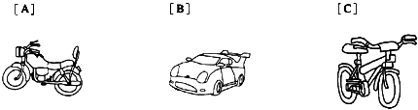
2．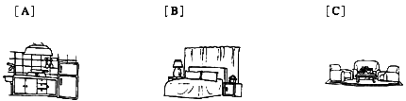
3．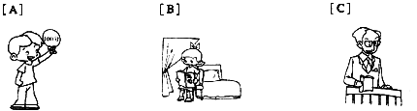
4．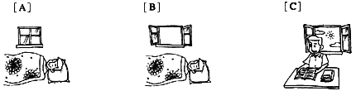
5．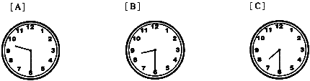
6．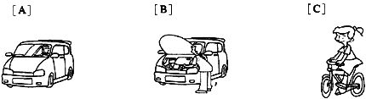
7．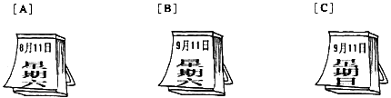
8．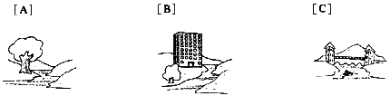
9．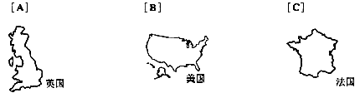
10．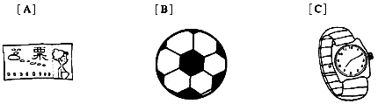
第二节 对话理解
在本节中，你将听到15段对话，每段对话有一个问题。请从[A]、[B]、[C]三个选项中选出答案，并标在试卷的相应位置。每段对话后有15秒钟的停顿，以便回答问题并阅读下一问题及其选项。每段对话读两遍。
下面，请听这些对话。
11. Who are they talking about?
[A] A man. [B] A woman. [C] A small child.
12. Where are they talking?
[A] In a post office. [B] In the street. [C] In a bank.
13. What are they talking about?
[A] Family. [B] Language. [C] Music.
14. What do we know about the man?
[A] He does not like playing the piano.
[B] He thinks the music lessons are useful.
[C] He does not like the music lessons.
15. What does the man mean?
[A] He needs more than one cup of coffee.
[B] He needs to sleep for three or four hours,
[C] He wants to buy a set of coffee cups.
16. Where are they talking?
[A] In a hospital. [B] In a restaurant. [C] In a police station.
17. What does the woman mean?
[A] She does not believe the weather report.
[B] She does not think it is going to rain.
[C] She agrees with the man.
18. What do we know about the woman?
[A] She has been to Japan only once.
[B] She has been to Japan twice.
[C] She has never been to Japan.
19. What does the woman tell the man to do?
[A] To make the call on her telephone.
[B] To go to find the closest telephone.
[C] To pay for the telephone call.
20. What does the man mean?
[A] He thinks the weather here is bad.
[B] He wants to go back home.
[C] He likes the weather here.
21. What do we know from the coversation?
[A] The woman knows where Lily is.
[B] The man wants to find Lily.
[C] Lily is in the next room.
22. What are they going to do together?
[A] To go to the airport. [B] To go to a meeting. [C] To have dinner.
23. How much will the man pay if he buys two shirts?
[A] 4 dollars. [B] 12 dollars. [C] 16 dollars.
24. What do we know about the woman?
[A] She has never seen a sunrise.
[B] She wants to watch the sunrise again.
[C] She went to the seaside with the man.
25. What do we know about the woman?
[A] She has already had two children.
[B] She does not want to have any children.
[C] She does not want to have a big family.
第二部分 英语知识运用
第一节 单项填空
阅读下面的句子和对话，从[A]、[B]、[C]三个选项中选出一个能填入空白处的最佳选项。
26. Are you good at ______ the piano, Tom?
[A] playing [B] play [C] to play
27. Your sister is sleeping. Could you ______ the radio?
[A] turn on [B] turn off [C] turn over
28. Children learn ______ from each other than from their teachers.
[A] much [B] more [C] most
29. I want to know how many ______ I should pay for the service.
[A] money [B] cash [C] dollars
30. We are happy that the 2008 Olympic Games ______ in Beijing.
[A] will be held [B] will hold [C] hold
31. All the information can ______ in this small computer.
[A] store [B] be storing [C] be stored
32. My parents, my aunt and my uncle ______ gave me a present on my birthday.
[A] each [B] every [C] either
33. Now I have a room ______ my own. It's next to Mary's.
[A] of [B] for [C] on
34. Not until I began to work ______ how difficult it was.
[A] I knew [B] I did know [C] did I know
35. Sally wants to become a singer when she ______ up.
[A] grows [B] grew [C] will grow
36. Nearly half of the students in this school ______ from Asia.
[A] is [B] comes [C] are
37.--Are you free tomorrow?
-- ______. I have to see my mother.
[A] I think so [B] I'm afraid not [C] That's right
38. The young boy usually eats what he wants ______ what he needs.
[A] because of [B] instead of [C] such as
39. When the meeting began, the two ladies stopped ______.
[A] saying [B] talking [C] telling
40. Sarah and Anna learned a bit of Japanese ______ they were in Japan.
[A] though [B] while [C] after
第二节 完形填空
阅读下面短文，从短文后所给的[A]、[B]、[C]三个选项中选出能填入相应空白处的最佳选项。
The most famous diary (日记) in English was written by Samuel Pepys. It (41) an interesting picture of everyday life in England (42) 1660 and 1669. Pepys writes about (43) news stories of the time, (44) the Great Fire of London. He (45) writes about himself, even about his wrong doings. He writes about his home (46) --a quarrel(吵架) with his wife and (47) they became friends again, and his worry about her illness. As well as books, he liked music, plays, card games and parties (48) good food and a lot of fun. Pepys was a busy man. He had many important (49) during his life. Now he (50) for what he did for Britain.
41. [A] gives [B] makes [C] takes
42. [A] from [B] among [C] between
43. [A] useful [B] beautiful [C] important
44. [A] like [B] for [C] with
45. [A] yet [B] also [C] only
46. [A] visit [B] office [C] life
47. [A] what [B] how [C] which
48. [A] in [B] by [C] with
49. [A] jobs [B] reasons [C] agreements
50. [A] remembers [B] is remembered [C] has remembered
第三部分 阅读理解
第一节 词语配伍
从上栏所给选项中选出与下栏各项意义相符的选项。
[A] plane
[B] bus
[C] seat
[D] ticket
[E] film
[F] conversation
[G] music
51. People buy it to get on a train or into a park.
52. People go to see it in a cinema.
53. It is a talk between two or more people.
54. It carries people along the road to another place.
55. It carries people and travels in the air.
第二节 短文理解 1
阅读下面短文，从[A](Right)、[B](Wrong)、[C](Doesn't Say)三个判断中选择一个正确选项。
Etiquette(礼节) is important at a Chinese dinner party. Usually, the host(主人) should politely ask the guests to be seated first before he sits down. If there is a speech, people stop eating and drinking to listen. Every time a dish is brought out, the host asks the guests to try it first. Guests would not start eating the dish until the host asks them to. While eating, people should stop often to talk for a while. Eating all the time without stopping is not polite, and could be laughed at. Usually, people do not finish a dish. A finished dish would suggest that there is not enough of the dish to eat, which may make the host embarrassed( 不好意思的), so people would not usually pick up the last piece off a plate. During a meal, the host asks the guests again and again to eat and drink more. Without this, some people may feel embarrassed about how much they eat. From time to time, people pick up food to give it to those sitting beside them. The host keeps the guests company all the way through the dinner. He would not finish until all the guests do so.
56. Etiquette at a Chinese dinner party in China is the same as that in western countries.
[A] Right. [B] Wrong. [C] Doesn't Say.
57. The host is not polite if he sits down at the table before the guests do so.
[A] Right. [B] Wrong. [C] Doesn't Say.
58. The guests should try a dish without being asked as soon as it is brought to the table.
[A] Right. [B] Wrong. [C] Doesn't Say.
59. The host should stay at the table until the dinner is over.
[A] Right. [B] Wrong. [C] Doesn't Say.
60. The guests should take home what is left of the food and drink after a meal.
[A] Right. [B] Wrong. [C] Doesn't Say.
第三节 短文理解 2
阅读下列短文，从[A]、[B]、[C]三个选项中选择一个正确答案。
Being away from their families during the holidays is one of the hardest things for most soldiers stationed(驻扎) far away.
Serena Ravenell, 35, has been stationed in Texas and misses her family back home in South Carolina. "I have a 5-year-old son and a daughter who just turned 2 years old. All I can do is talk with them on the phone." Ravenell said.
Many soldiers are stationed in other countries, but even being not very far away in their own country can be heartbreaking. For their families left behind, the holidays can be a hard time.
"Right now my husband is Mr. Mom. He takes care of the children," Ravenell said.
In Ravenell's unit(部队), many women have children or are single mothers. Most of them have relatives(亲戚) taking care of their children while they are away.
"Leaving my little girl was hard. My husband has done a good job, but I think all children need their mothers for those early years," Ravenell said. "Leaving was something that I did not want to, but I knew I had to do."
61. During the holidays most soldiers ______.
[A] miss their families very much
[B] ask to go home to see their families
[C] have the pleasure of staying with their families
62. Where does Serena Ravenell serve as a soldier?
[A] In Texas.
[B] In South Carolina.
[C] In a foreign country.
63. How many children does Serena Ravenell have?
[A] Two. [B] Three. [C] Four.
64. What does Serena Ravenell say about her husband?
[A] His name is Mom.
[B] He looks after their children.
[C] He is a full-time father.
65. What do we know about Serena Ravenell?
[A] She is the only woman in her unit.
[B] She has many relatives in her unit.
[C] She thinks mothers' care is important to children.
24 March
Dear Julie,
I'm sorry I haven't written for a while, but I've been busy at work and have spent almost all my spare time looking for a flat(公寓). I saw a really nice place this morning--a third floor flat with two bedrooms. I have been tired of living in this hotel.
I met a very nice Japanese couple(夫妇) the other night and they've asked me to spend a weekend with them at their house in the country. It'll be nice to get away from Tokyo for a few days. The only problem is that they don't speak much English, and my Japanese is still very poor.
By the way, I can't remember if I thanked you for the things you sent me. Believe me, they'll be really useful when I get a flat and start doing a bit of cooking for myself.
I'm afraid I'll have to finish now. Sorry it's a short letter but I've planned to go out with some friends. I'll write again at the end of the week. Until then, take care of yourself and give my love to Tim.
Love,
John
66. What does John do most of the time when he is not working?
[A] He goes out with friends.
[B] He takes Japanese lessons.
[C] He looks for a place to live in.
67. How does John feel about living in the hotel?
[A] He is happy to live in the hotel.
[B] He does not like living in the hotel.
[C] He does not care whether he lives in the hotel or not.
68. Julie has sent John something to be used in the
[A] kitchen [B] bedroom [C] living-room
69. Why didn't John write a longer letter?
[A] He was fired
[B] He had to go out.
[C] He had nothing more to say.
70. What can we learn about Julie?
[A] She speaks good Japanese.
[B] She wrote a letter to John on March 24.
[C] She hasn't heard from John for some time.
第四部分写 作
第一节 改写句子
下面是关于David乘坐公共汽车的三对句子。每对句子中，第一句是原句，第二句是对第一句的改写。要求根据原句和第二句中已经给出的部分用一至五个单词补全第二句。把补出的部分写到横线上。注意不能改变原句的意思。
71. It was already seven o'clock when David left home.
David ______ home until seven o'clock.
72. He missed the bus though he ran very fast.
He didn't ______ the bus though he ran very fast.
73. He had to wait for the next bus for half an hour.
It would ______ him half an hour to wait for the next bus.
第二节 书面表达
74．情景：
你的外国朋友Tom要来你居住的城市旅游，希望你向他推荐一家旅馆。
任务：
请你给Tom写一封50个词左右的短信。内容包括：
·旅馆的名称和位置；
·旅馆的设施和服务；
·旅馆的联系方式。
请用下面格式。
Dear Tom.
Li Min
2007年9
1. C 2. A 3. A 4. B 5. B 6. A 7. B 8. C 9. B
10. A 11. C 12. B 13. C 14. B 15. A 16. A 17. B 18. C
19. A 20. A 21. B 22. C 23. B 24. B 25. C 26. A 27. B
28. B 29. C 30. A 31. C 32. A 33. A 34. C 35. A 36. C
37. B 38. B 39. B 40. B 41. A 42. C 43. C 44. A 45. B
46. C 47. B 48. C 49. A 50. B 51. D 52. E 53. F 54. B
55. A 56. C 57. A 58. B 59. A 60. C 61. A 62. A 63. A
64. B 65. C 66. C 67. B 68. A 69. B 70. C
71. didn't leave 72. catch 73. take
74. 范文:
Dear Tom,
I am glad to hear that you will come to Beijing for your holiday travel. I have chosen one hotel for you. Its name is Mengxi Hotel, which lies in the cross of Xuanyuan Street and Chengfu Road. It is of first-class facilities and services of high-qualities. I believe you will enjoy it. You can contact it at 86-010 -88237829.
Looking forward to your early coming.
Yours'
Li Min
2007年9 月笔试真卷听力录音稿
1. Would you show me the blue bike in the window please?
2. I think there is still some food left in the kitchen.
3. Tom is a bright child, and he is very good at his school work.
4. Jack always sleeps with the window open.
5. I usually get up at half past eight in the morning on weekends.
6. Mr. White is now learning to drive a car.
7. It's September 11 today and it's Saturday.
8. The bridge across the river is about one hundred years old.
9. All her shoes are made in the United States.
10. They were happy to get the last two tickets for the play.
11. M: Isn't he a lovely baby? Can he talk yet?
W: No, he can't. But he will soon be able to.
12. W: Excuse me, could you tell me where the post office is?
M: Just turn right and you will see it beside a bank.
13. M: I often listen to light music at home. What kind of music do you like ?
W: I really enjoy Chinese music.
14. W: How are your piano lessons going?
M: Very well, mum. I find the lessons worth the time.
15. W: You look tired Sam. Would you like a cup of coffee?
M: A cup of coffee. I think I need three or four.
16. W: Good morning, Sir. What's wrong with you?
M: I have a bad cold, and I can't sleep well.
17. M: Look at that dark cloud. I am afraid it's going to rain.
W: I don't think so. The weather report says it will be fine today.
18. W: I'm going to Japan this autumn. This will be my first visit to the country.
M: Oh, I've been there twice.
19. M: Where is the closest telephone, Mary?
W: Why not use mine, Tom? I won't ask you to pay.
20. W: Are you looking forward to going back home?
M: Not really. The weather here agrees with me.
21. M: Do you know where Lily is?
W: She was here. Hm... Try then next room.
22. W: If you're going to the airport, what about our dinner?
M: I'll meet you for dinner after I've been to the airport.
23. M: This shirt looks very nice. How much is it?
W: It's eight dollars if you buy one. But you pay four dollars less if you buy two.
24. M: I just went to watch the sunrise at the seaside.
W: Why didn't you tell me? It's five years since I last saw it.
25. M: Ann, do you and your husband plan to have many children?
W: Only two. It's expensive to have a big family now.

